**ASSIGNMENT-1**

**DATA MODULE:**

**LINK:**

<https://us3.ca.analytics.ibm.com/bi/?perspective=ca-modeller&pathRef=.my_folders%2Fsupermarket%2Bdatamodule>

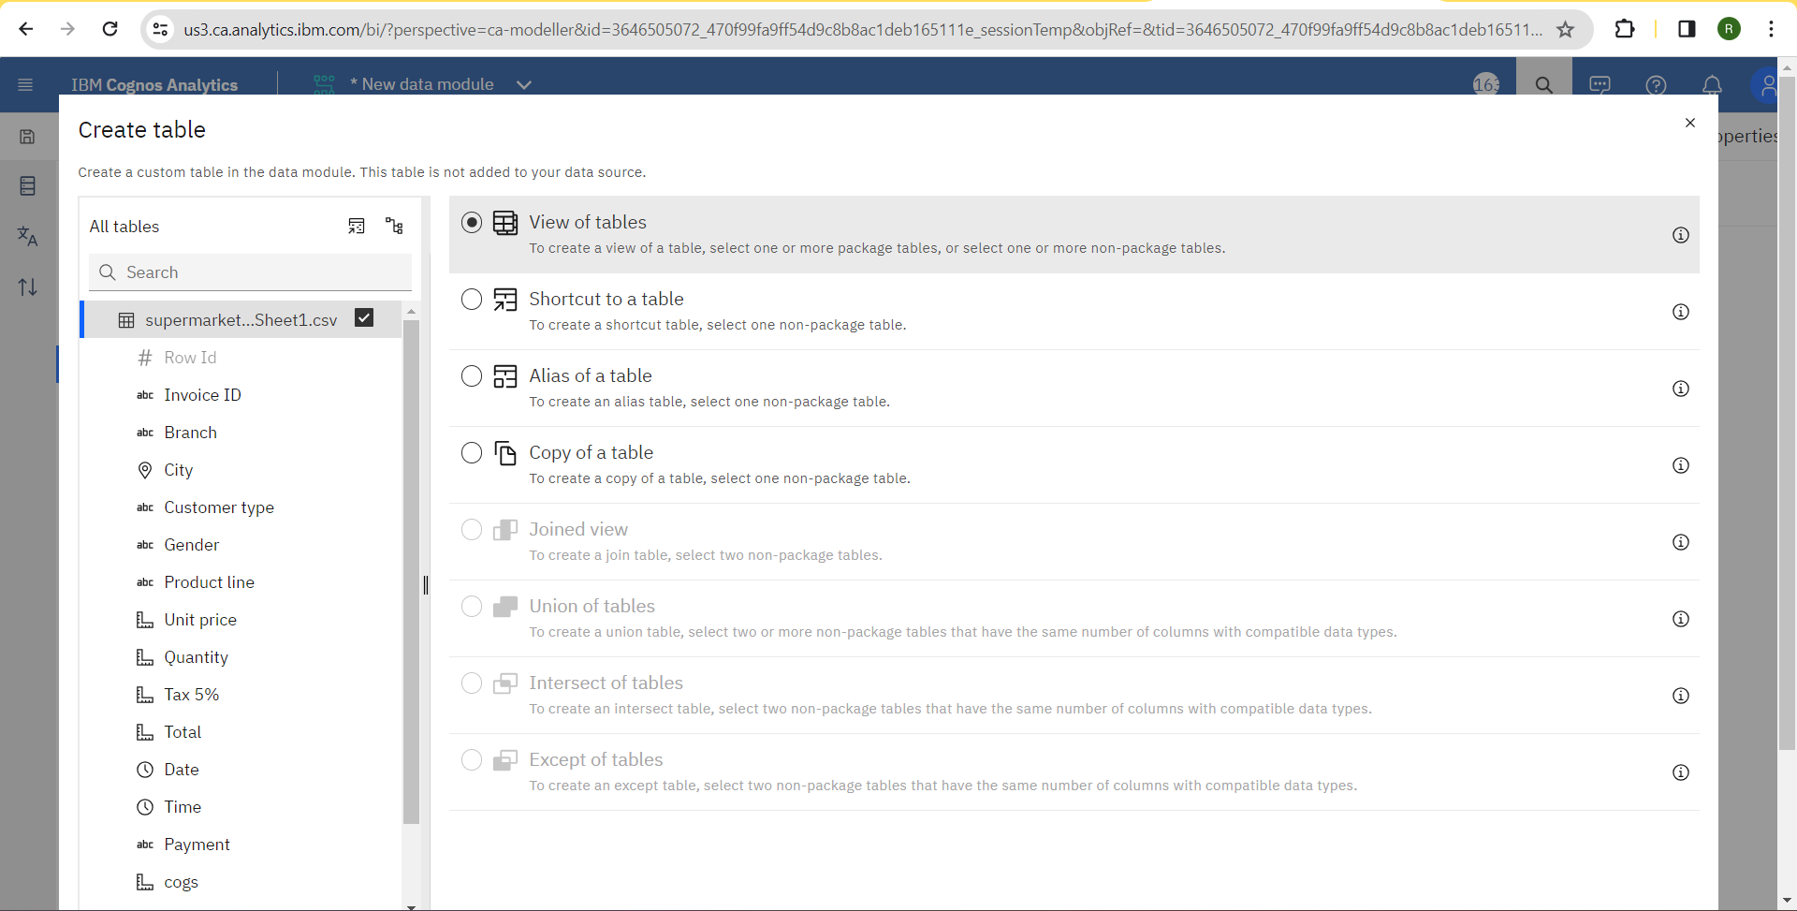

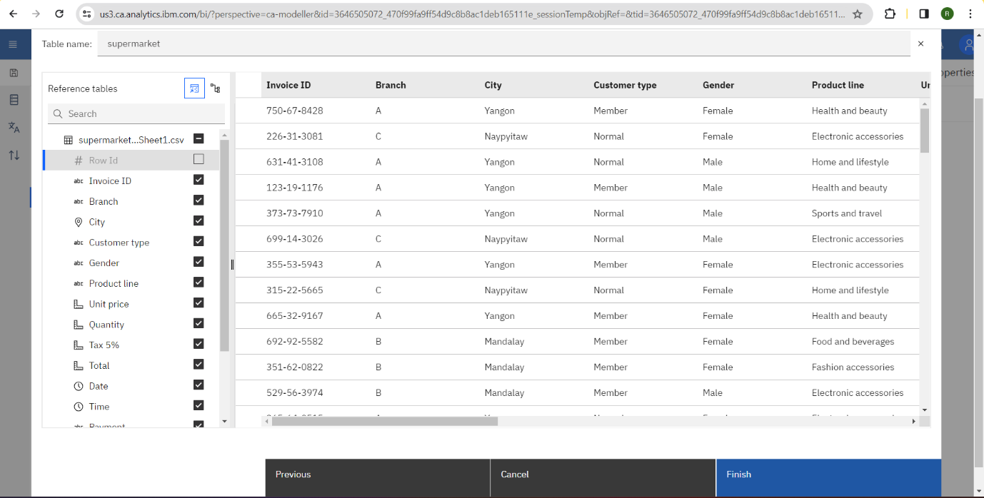

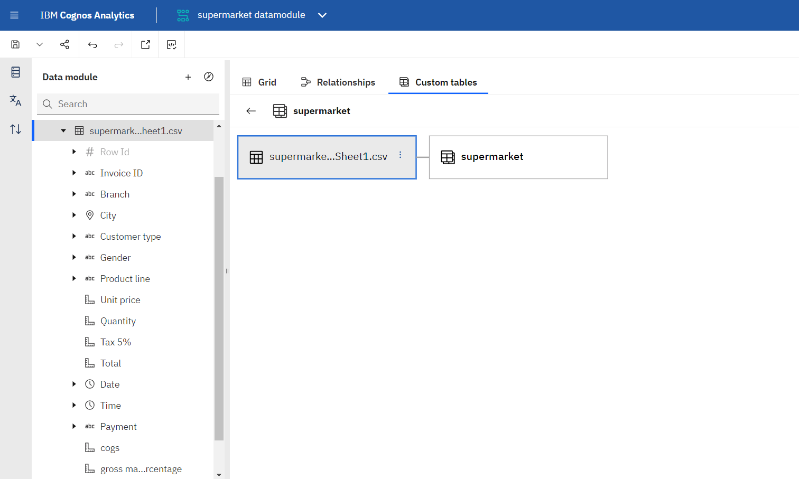

**EXPLORATION:**

**LINK:**

<https://us3.ca.analytics.ibm.com/bi/?perspective=explore&pathRef=.my_folders%2Fsupermarket%2Bexploration&subView=model0000018b6c361b32_00000005>

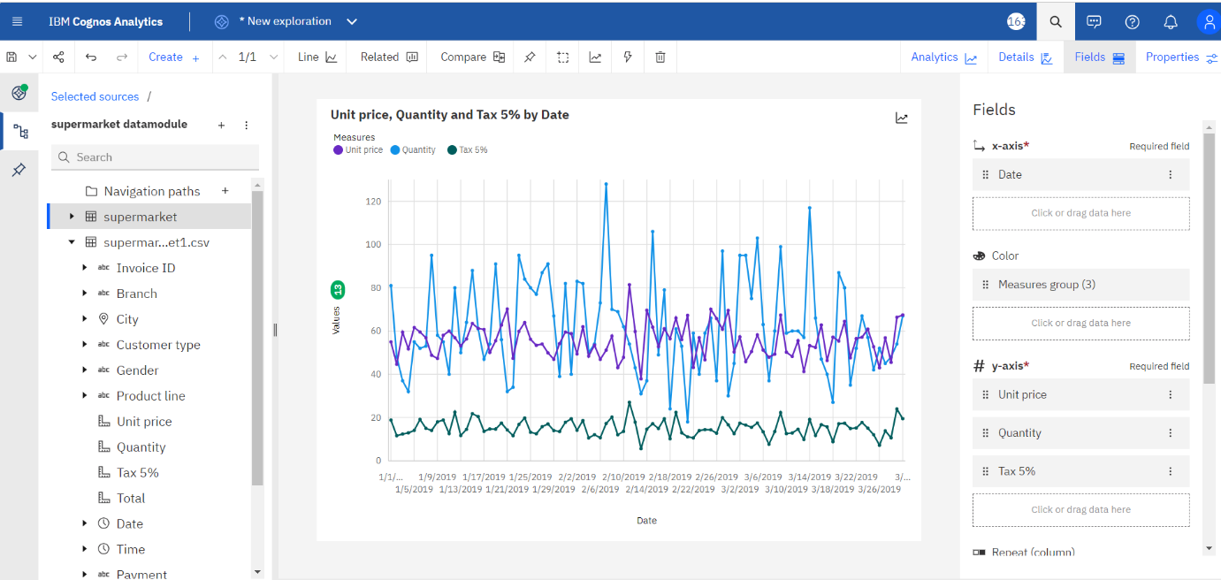

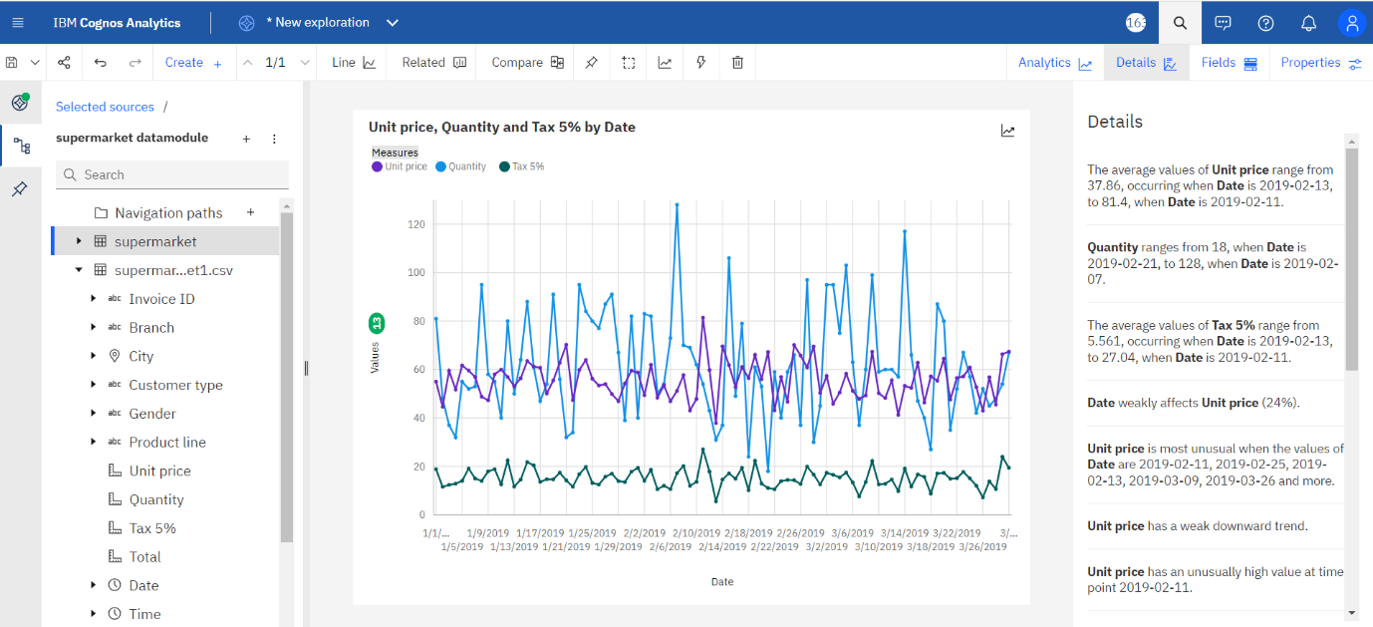

**LINK:**

<https://us3.ca.analytics.ibm.com/bi/?perspective=explore&pathRef=.my_folders%2Fsupermarket%2Bexploration&subView=model0000018b6c3f443c_00000004>

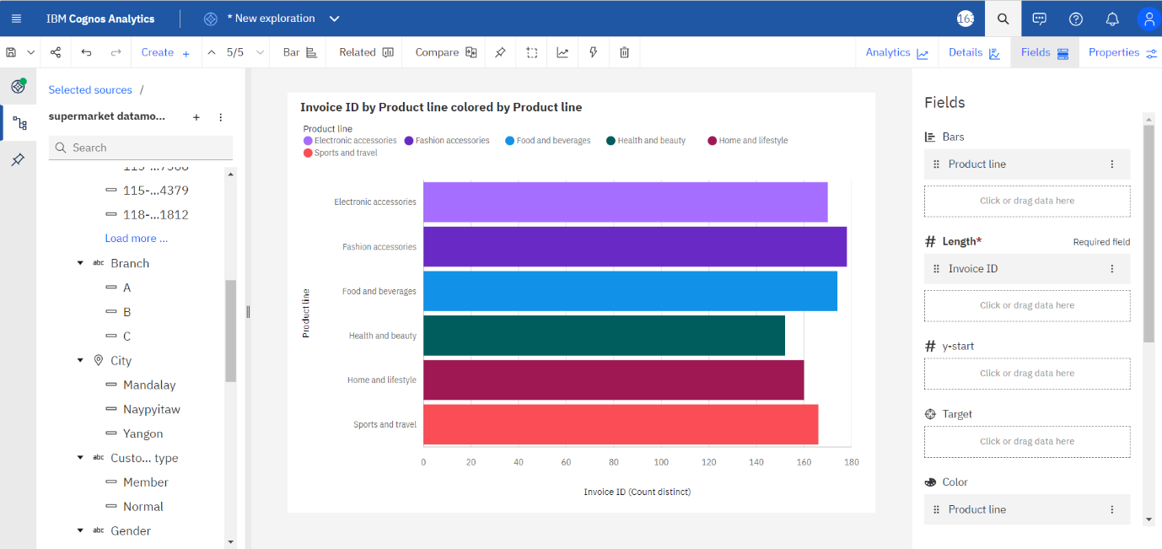

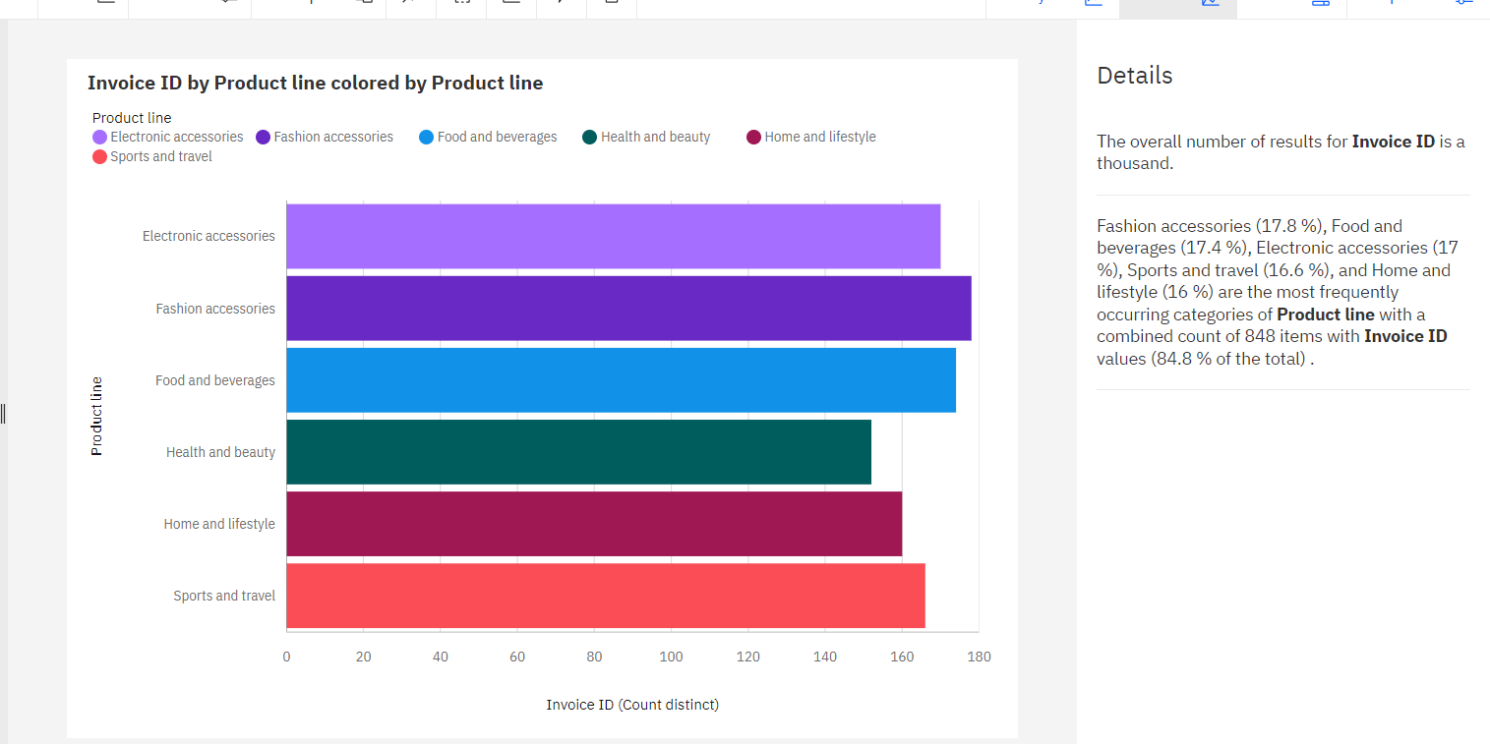

LINK:

<https://us3.ca.analytics.ibm.com/bi/?perspective=explore&pathRef=.my_folders%2Fsupermarket%2Bexploration&subView=model0000018b6c5068f1_00000003>

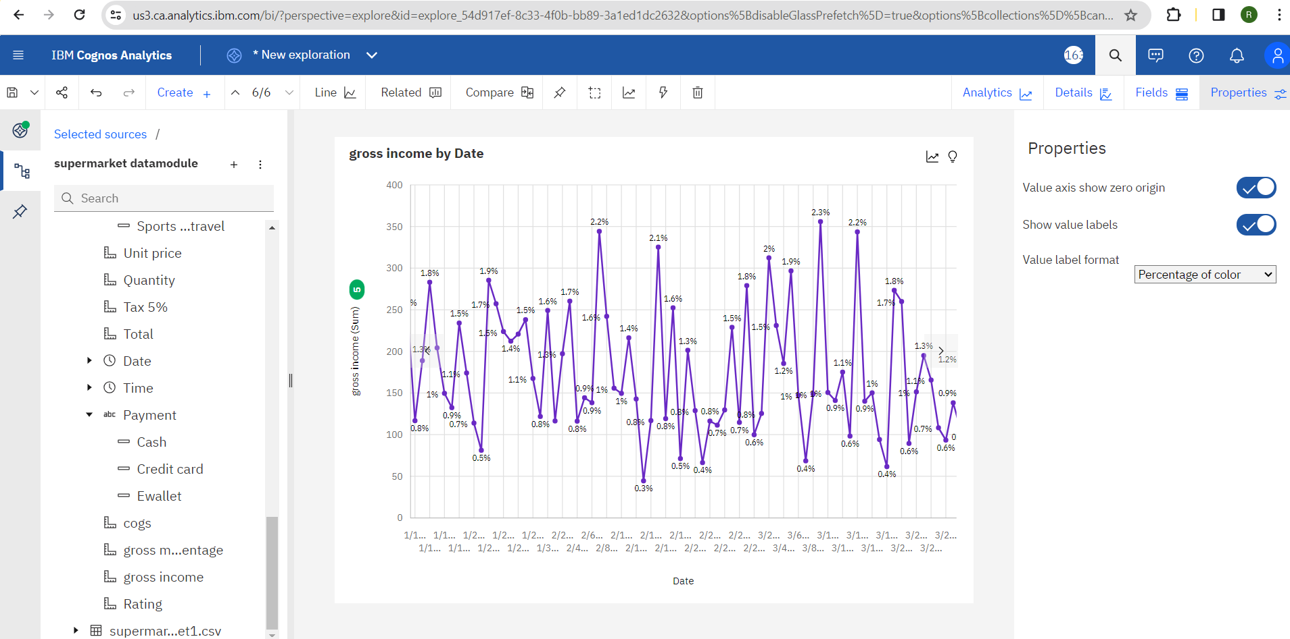

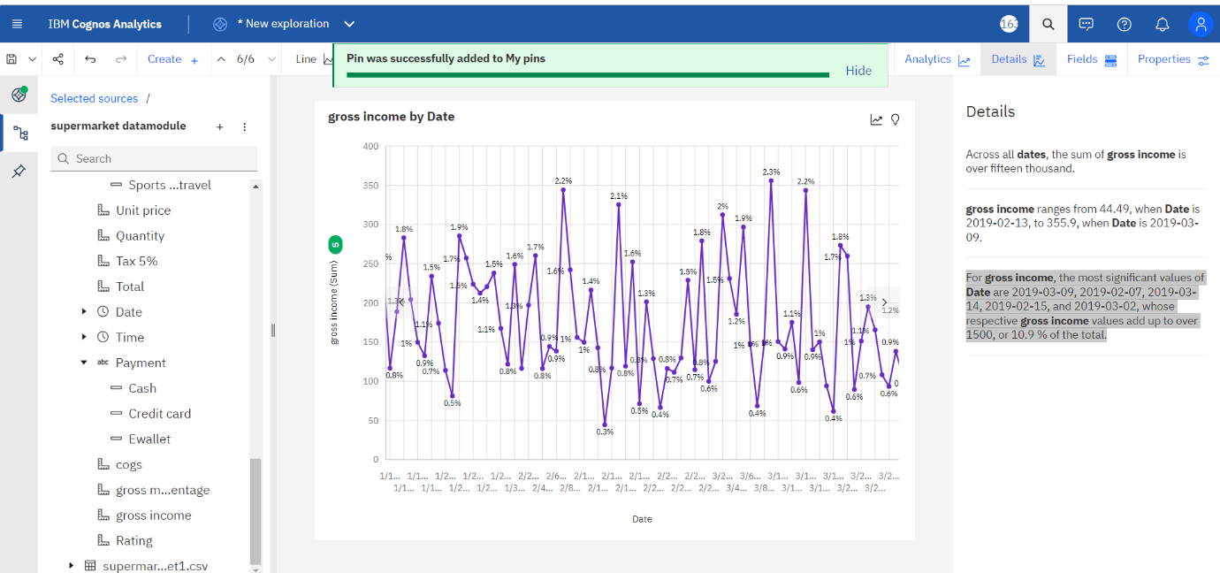

LINK:

<https://us3.ca.analytics.ibm.com/bi/?perspective=explore&pathRef=.my_folders%2Fsupermarket%2Bexploration&subView=model0000018b6c55f91b_00000004>

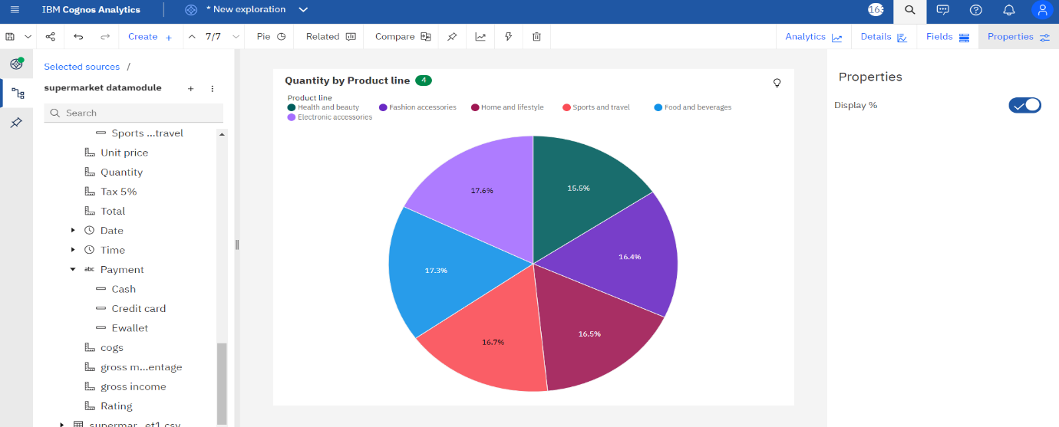

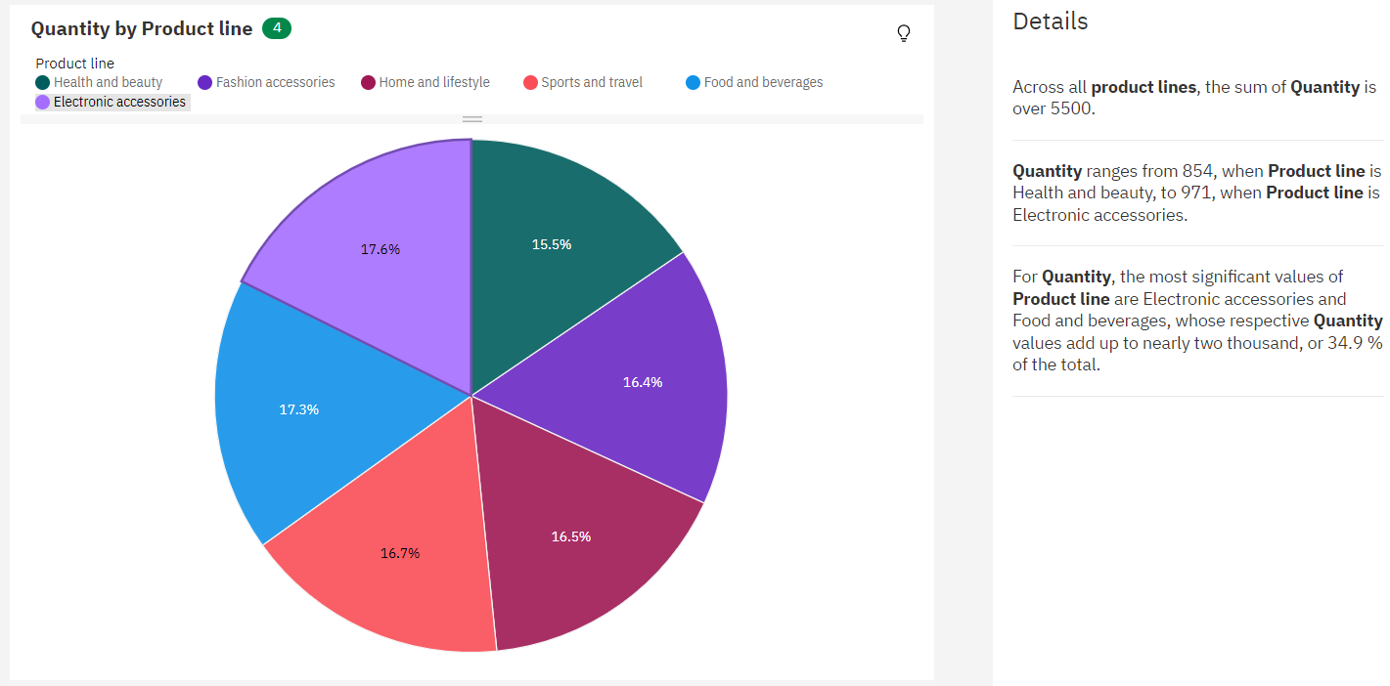

**LINK:**

<https://us3.ca.analytics.ibm.com/bi/?perspective=explore&pathRef=.my_folders%2Fsupermarket%2Bexploration&subView=model0000018b6c5a59f7_00000004>

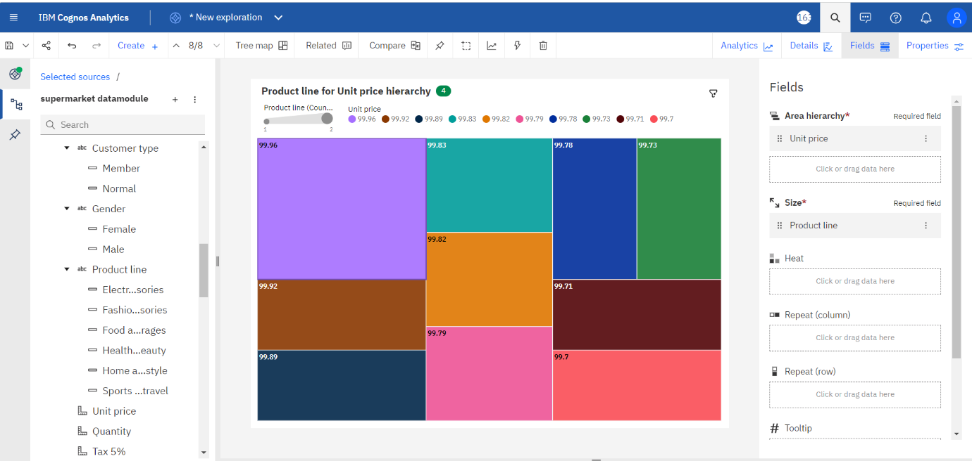

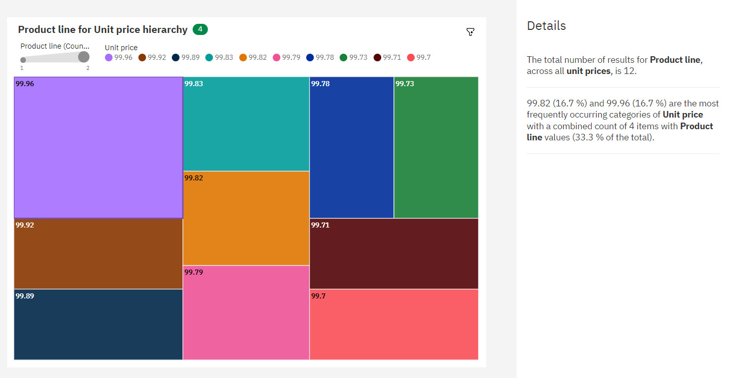

**LINK:**

<https://us3.ca.analytics.ibm.com/bi/?perspective=explore&pathRef=.my_folders%2Fsupermarket%2Bexploration&subView=model0000018b6c6e78b4_00000004>

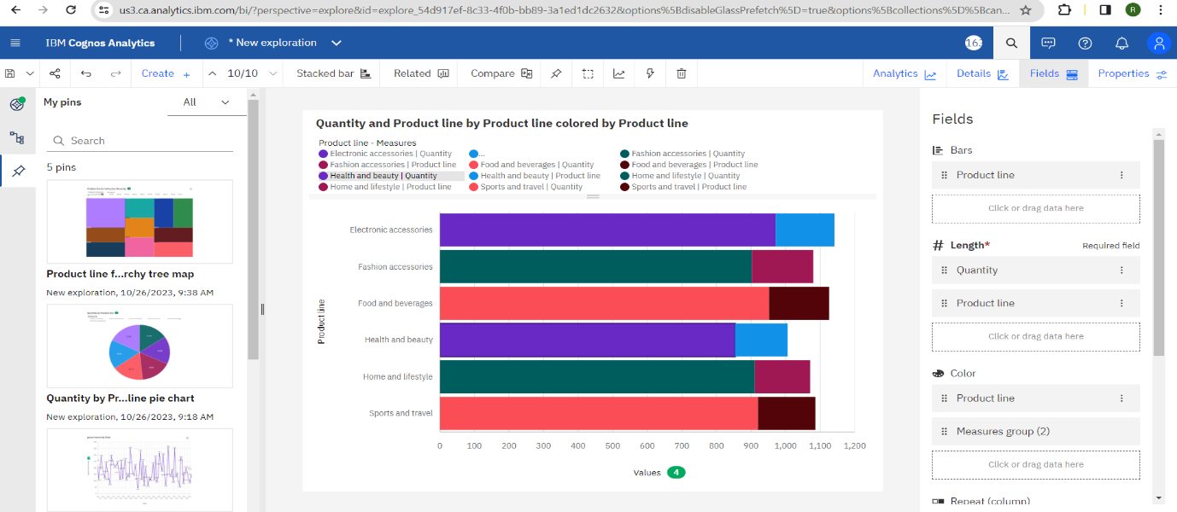

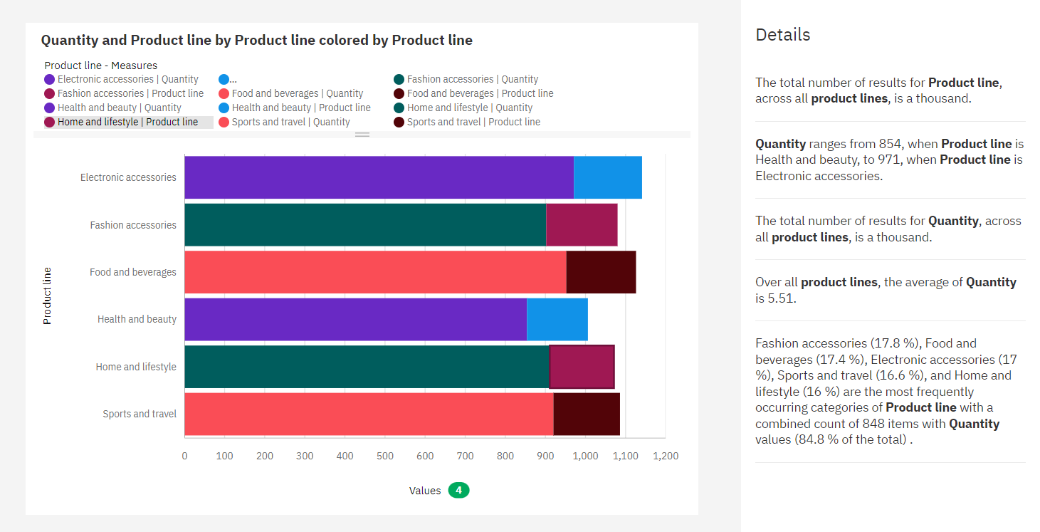

**LINK:**

<https://us3.ca.analytics.ibm.com/bi/?perspective=explore&pathRef=.my_folders%2Fsupermarket%2Bexploration&subView=model0000018b6c76e253_00000004>

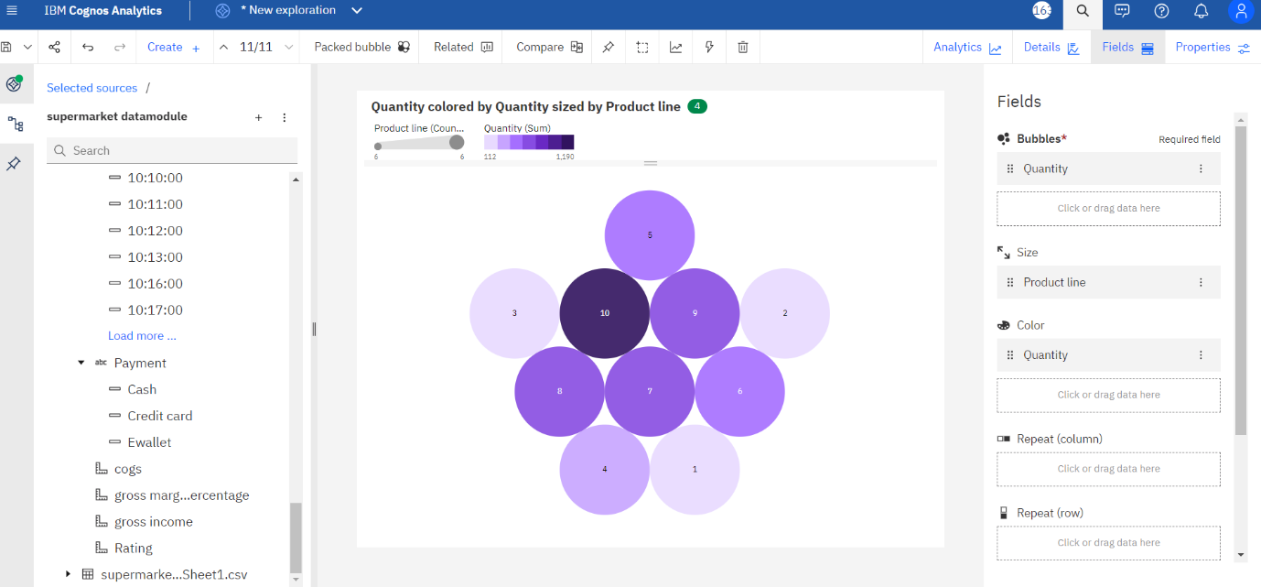

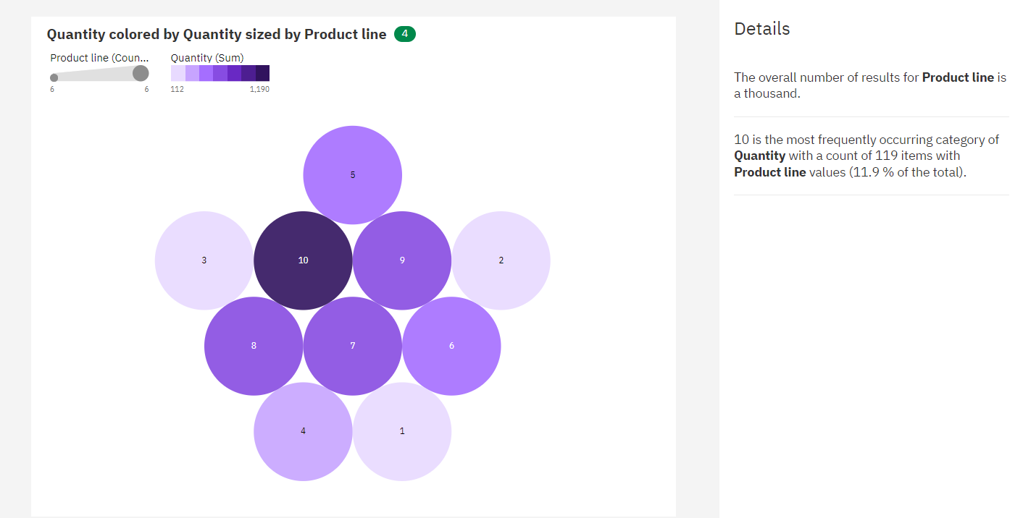

**LINK:**

<https://us3.ca.analytics.ibm.com/bi/?perspective=explore&pathRef=.my_folders%2Fsupermarket%2Bexploration&subView=model0000018b6c84b63e_00000004>

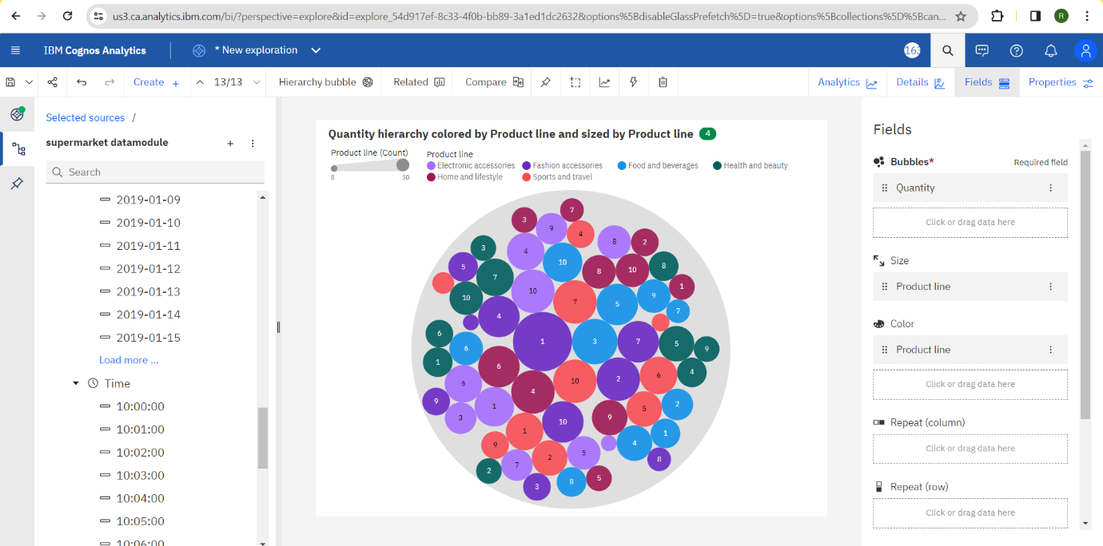

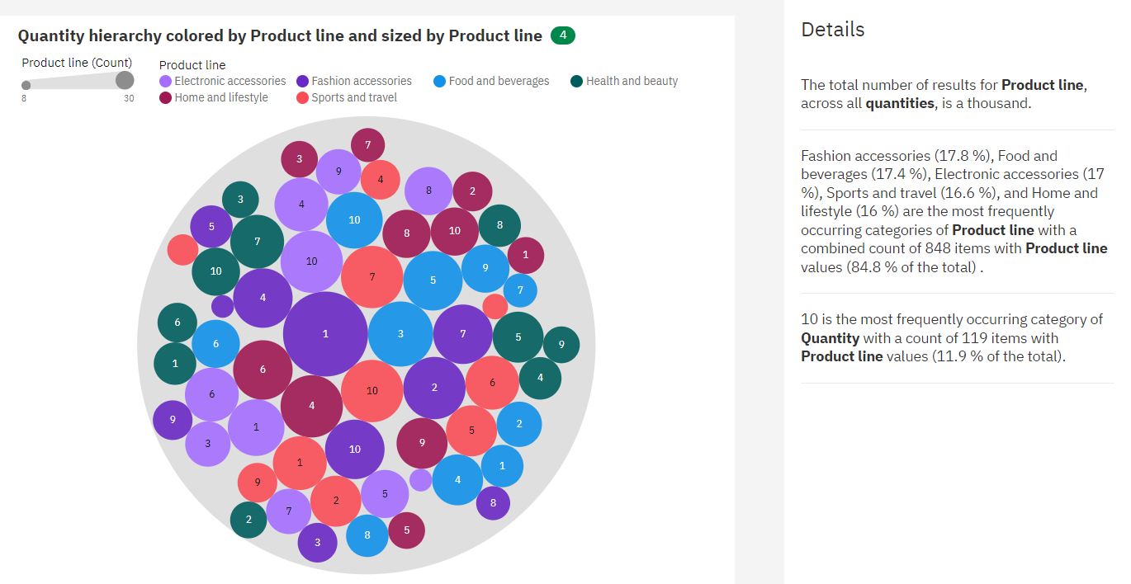

**DASHBOARD:**

**LINK:**

<https://us3.ca.analytics.ibm.com/bi/?perspective=dashboard&pathRef=.my_folders%2Fsupermarket%2Bdashboard&action=view&mode=dashboard&subView=model0000018b6c92125c_00000003>

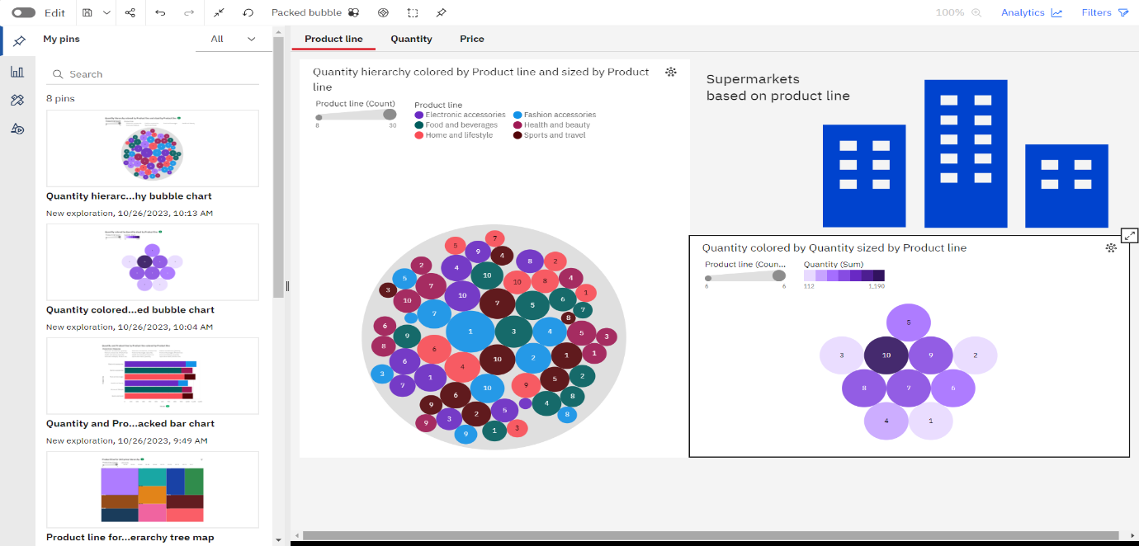

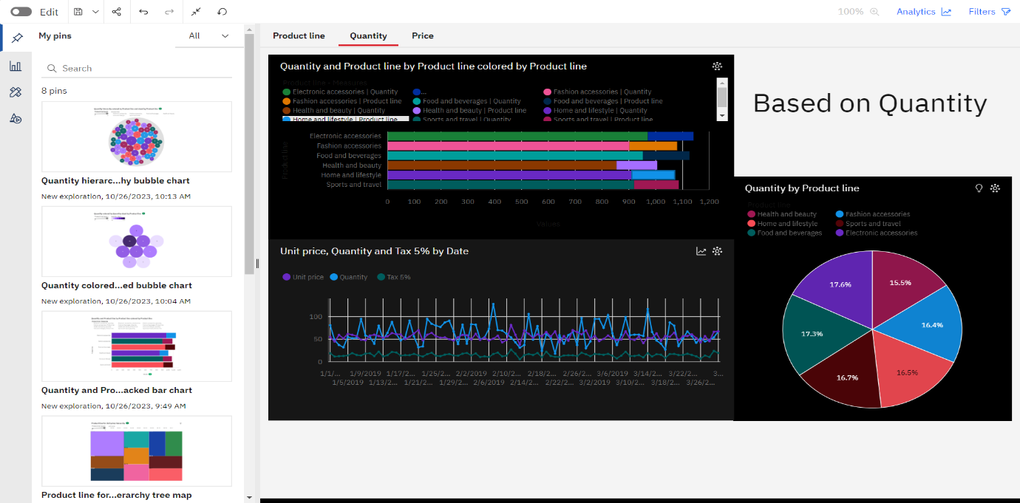

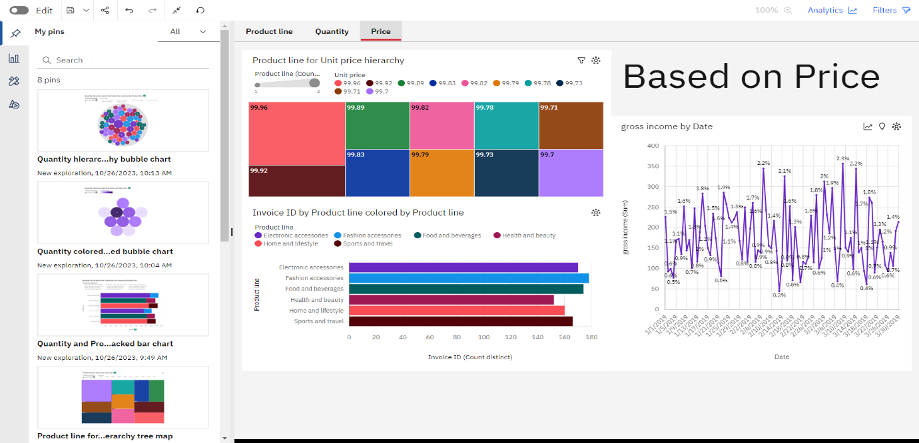

**REPORT**

**LINK:**

<https://us3.ca.analytics.ibm.com/bi/?pathRef=.my_folders%2Fsupermarket%2Breport&action=edit>

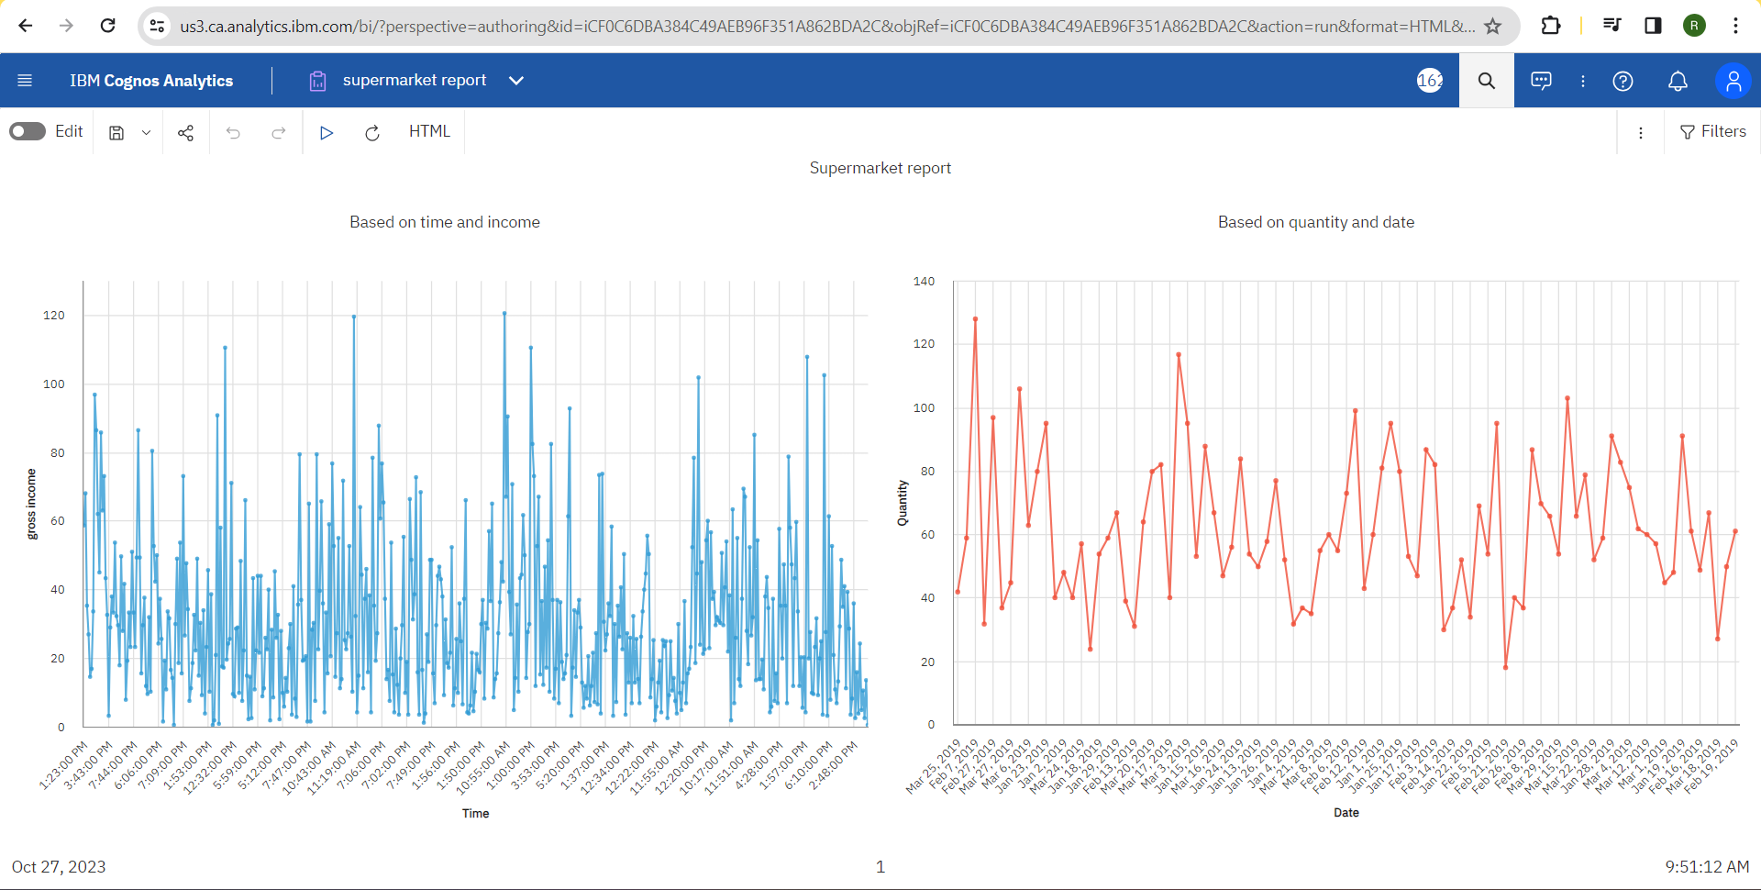

**STORY:**

**LINK:**

<https://us3.ca.analytics.ibm.com/bi/?perspective=story&pathRef=.my_folders%2Fsupermarket%2Bstory&action=view&sceneId=model0000018b6d0d0c7a_00000000&sceneTime=5000>

